**Virtual Memory Management Simulation**

* **Introduction**

This project is about memory management and virtual memory in particular. It consists of writing a simulator for experimenting with page replacement algorithms.

The primary goal for the project is to implement and experiment with page replacement algorithms. To do this, I will write a paging simulator. It will read in a set of data files specifying the page traces for individual jobs and will need to simulate the paging requirements of those programs.

* **Simulator General Graphical User Interface (GUI)**

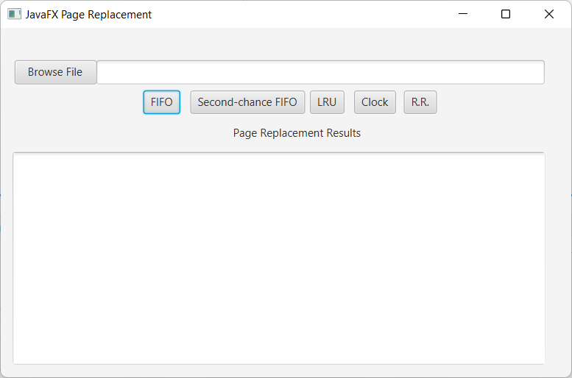

To browse the configuration file by user

5 page replacement algorithms

Result area for each running algorithm.

* **Configuration file Format**

The file name “**configuration_file.properties”** is a properties file which can be parsed by JavaFX project to read its key-value parameters.

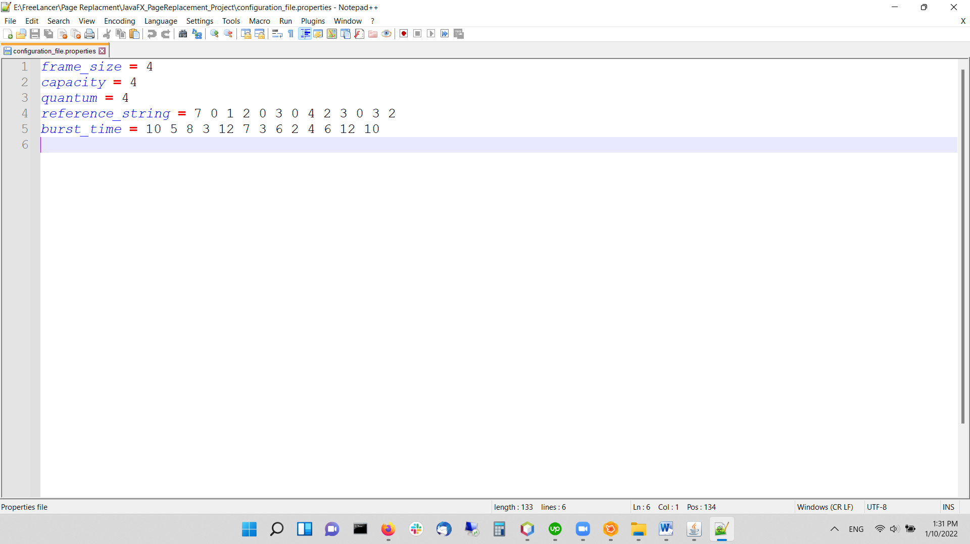

1. **frame_size**: displays the physical memory in frames.
2. **capacity**: the minimum frames per process.
3. **quantum**: A small unit of time. A time quantum is generally from 10 to 100 milliseconds. The ready queue is treated as a circular queue. It’s used by Round-Robin Scheduling.
4. **reference_string**: is the reference PID for the running processes. In this project for test I have 13 processes.
5. **burst_time**: is the duration for each process.

**NOTE**: these values and configuration can be edited while the simulator is running and take effect in place.

* **JavaFX Project Components**

1. Apache NetBeans IDE 12.5
2. JDK 16.0.2
3. Openjfx version 17.0.1
4. 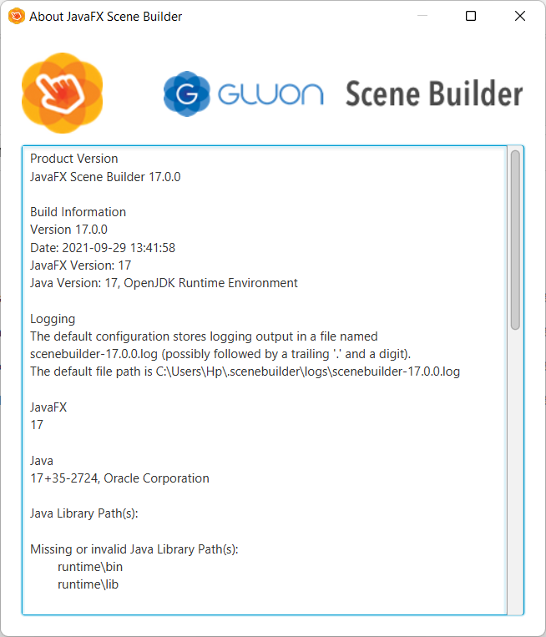JavaFX Scene Builder 17.0.0
5. 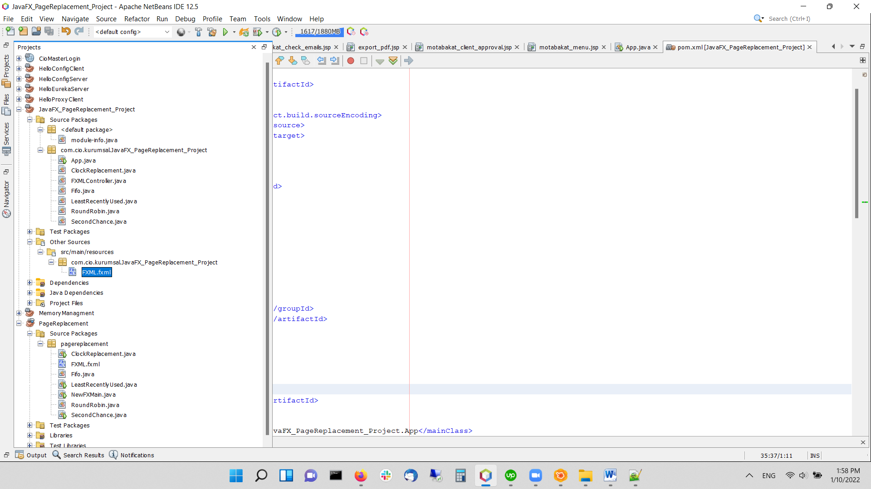Project general hierarchy

* **Running Project**

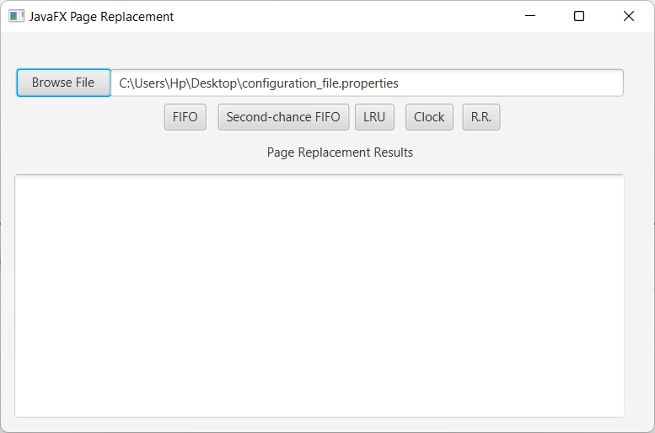Step 1: Selecting the configuration file.

Step 2: Running FIFO Algorithm

FIFO give page fault equals to 7 as shown below in result area.

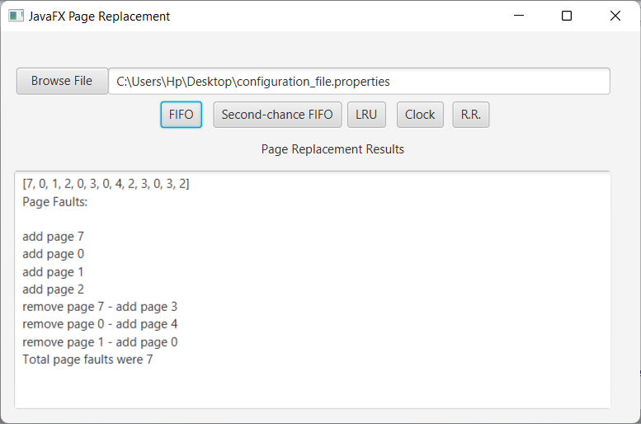

Step 3: Running Second-Chance FIFO Algorithm

Second-Chance FIFO give page fault equals to 6 as shown below in result area.

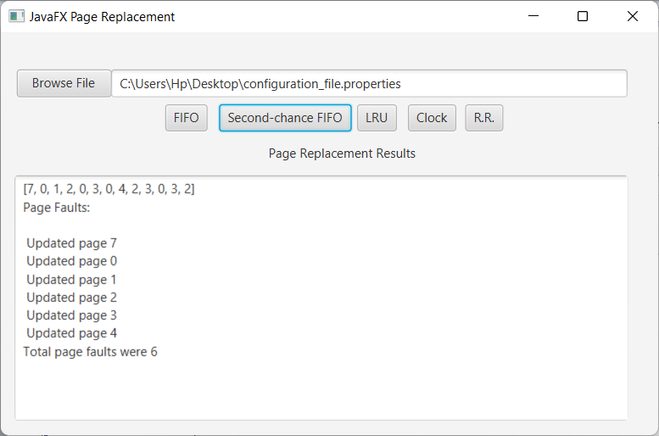

Step 4: Running LRU Algorithm

LRU give page fault equals to 6 as shown below in result area.

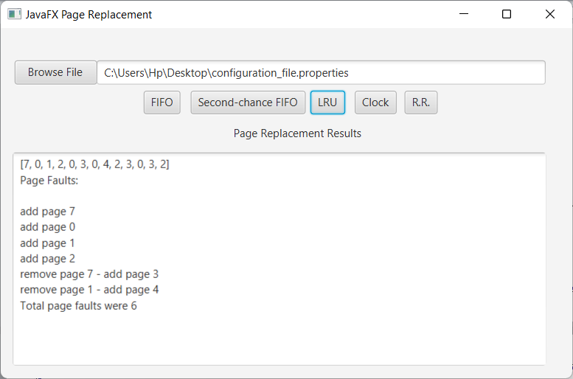

Step 5: Running Clock Algorithm

Clock give page fault equals to 6 as shown below in result area.

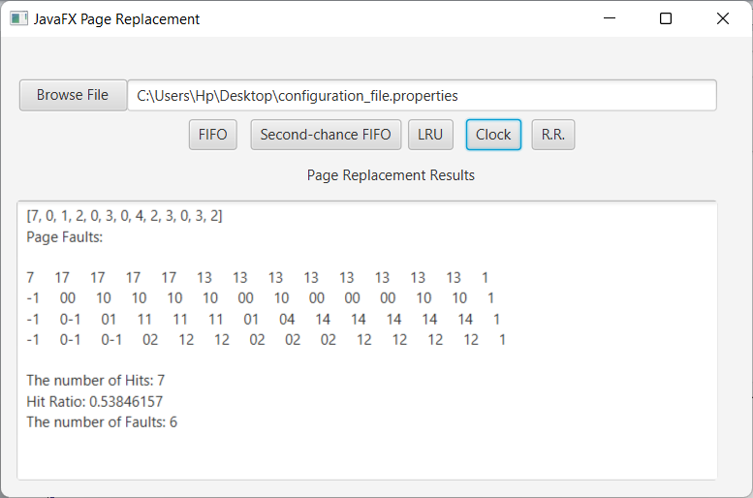

Step 5: Running Round-Robin Algorithm

Clock give page fault equals to 6 as shown below in result area.

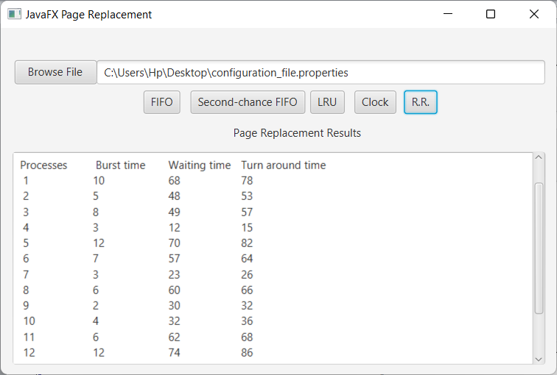Average waiting time = 51.0. Average turnaround time = 57.76923